1. Our market of interest is the market of Cocoa in West Africa at farm level, the characteristic of this market is that the products, which refers to the cocoa, are similar and can be considered as identical products. One more characteristic of this market is that it has low barrier of entry to the market, the difficulty of market entrance is very low, it may be due to the flexibility in scale, while large-scale farming may require significant capital and resources, individuals or small groups can start their own small-scale farming operations. This shouldn’t be difficult for them as the basic knowledge of farming techniques is not a secret and is widely available. Another characteristic of Cocoa market arises from this low barrier of entry to market is that it has many competitors, and the competition is high. The vast number of competitors in the market may be also because of the cocoa-producing belt of West Africa contributing over 80% of total global output and Cocoa being the vital component of West Africa’s countries economy. Due to this high competition, the farmers are usually the price taker. Therefore, I can conclude that the market structure of perfect competition best describes the market of Cocoa in West Africa at farm level.

Our market of interest is the market for Chocolate confectionary in Kuala Lumpur, the characteristic of this market is that it has a large variety of products, the products are very differentiated and not identical. This variation arises from the diversity of consumer taste and preferences. The barrier of entry to this market is also relatively low and therefore has a lot of competitors in the market, new entrants can immediately capture market share if they have a unique selling point, for example new flavours of chocolate. Due to the differentiation of product, firms usually have market power and takes control over the price, which can then be considered as price maker. Therefore, I have sufficient evidence to claim that the market structure of monopolistic competition best describes the market of chocolate confectionery in Kuala Lumpur.

1. 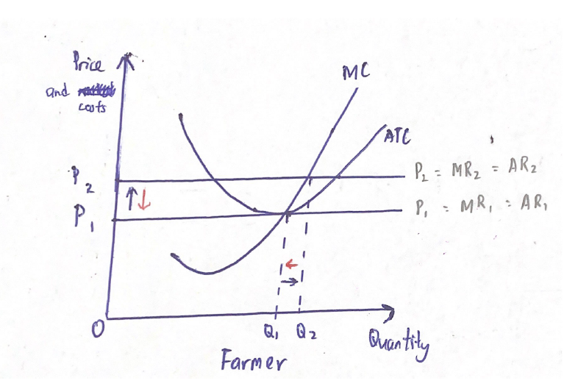Overall, the prices of Cocoa had increased substantially for the past year. Ghanaian cocoa prices in Europe were US$497 per tonne in June 2023, a 45% increase from US$344 per tonne in June 2022. According to the ICCO's (International Cocoa Organisation) most recent data, the origin difference increased for Ivorian and Ecuadorian cocoa beans by 67% and 13%, respectively, from US$240 to US$402 and US$370 to US$418 per tonne. A diagram of price and quality

   Description automatically generated

According to the graph above, we can observe that the price increased from P1 to P2 when the supply curve shifted left from S1 to S2, while the demand curve remained the same. This resulted in a new equilibrium point, from E1 to E2, and that’s what have been happening in the Cocoa market in West Africa. According to recent reports from Ghana's cocoa regulator, some of the obligations under cocoa contracts may not be met by farmers for a subsequent season. Ghana's anticipated output of cocoa for the 2022–2023 planting season was 24% below the earlier forecasts of 850,000 metric tonnes, the lowest in 13 years. Across the region, this pattern has been observed, with production declining in Cameroon and Côte d'Ivoire also. This may be due to both short term and long-term factors, examples of short-term factors can be poor weather condition and shortage of fertilisers and pesticides, whereas long term factors are like declining availability of forest land which leads to increased production costs.

The price in perfect competition market structure is the same as the marginal revenue and the average revenue. Initially, the Cocoa farmers in West Africa are making zero economic profit, however, as prices increased from P1 to P2 due to decreased production of Cocoa, the price of Cocoa will increase as the blue arrow shown and be above the ATC curve, which represents the average total cost, whereas the quantity may increase or decrease, this depends on the extent of the shifts. As the price is greater than the average total cost at its production level, this indicates that the farmers are making positive economic profit. In the long run, this will attract more farmers to enter the market and plant Cocoa. Therefore, as there will be more farmers, the supply of Cocoa will increase and therefore the supply curve will shift right. Due to the shifting of the supply curve, this will cause the price of Cocoa to fall back from P2 to P1, as the red arrow shown, farmers will move down the MC curve, which represents the marginal cost of Cocoa. Eventually, zero economic profit will be restored.

3.

Farmer

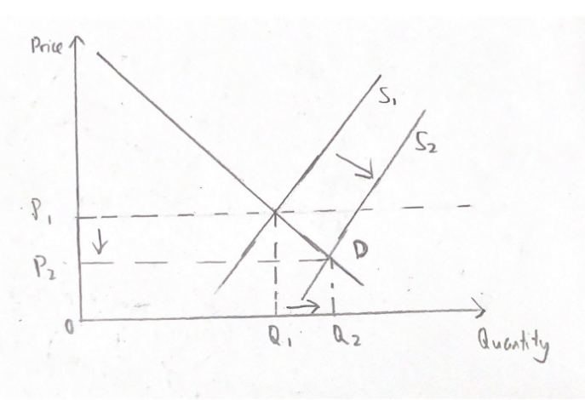

Farmer

Market

Initially, without the new technology of controlling weather, the price and average total cost would be the P1 and ATC1 curve as shown in the graph above. However, after the introduction of the new technology, poor weather conditions will no longer be an issue to the farmers. This causes the marginal cost and average total cost of Cocoa to decrease, the MC2 and ATC2 curve will be the new marginal and average total cost curve after the governments of West African Countries have the new technology to control the weather. As the price remains at P1, the price of Cocoa is greater than the average total cost at its production level, this implies that the farmers are making positive economic profit. In the long run, this will attract more farmers to enter the market, which causes the supply curve to shift to the right. The price of Cocoa will then decrease from P1 to P2 due to the shifting of the supply curve, the demand curve remains the same as the hypothetical situation did not state what will happen to the market demand.

The graph shown above is the long run average cost curve, the curve changed from LRAC1 to LRAC2 due to the introduction of the new technology. Farmers have now moved to the new LRAC. Eventually, as price decreases, market price fall, and all farmers in the market enjoys zero economic profit.

4.

Firm

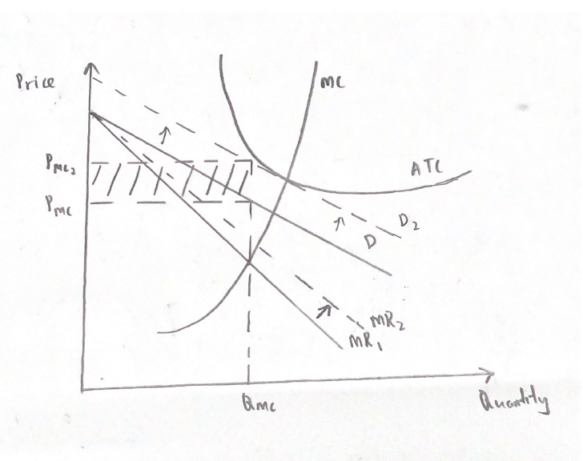Initially, as the monopolistic competition have low barrier of entry, firms often earn zero economic profit in the long run. Therefore, as the Cocoa price increases, this will cause the average total cost, which is represented by the ATC curve to be above the price of chocolate, Pmc, shown in the graph above. The graph implies that Royce chocolate outlets in Kuala Lumpur are incurring economic losses. The shaded region is the region of economic loss. The demand curve in the graph only represents the demand for Royce chocolate, and not the demand for the entire chocolate market. The demand curve is always downward sloping in monopolistic competition market as the product is differentiated from others. In short run, Royce produces chocolate output at which MR=MC, the point where marginal cost equals to marginal revenue, to maximise profit. The price is often set at the point where the production level meets the demand curve.

Firm

In long run, as Royce is suffering from economic loss, this pushes other chocolate firms to leave the market, and therefore the demand for Royce chocolate will increase, as consumers can no longer find substitutes to replace Royce chocolate. Consequently, the demand curve shifted right from D to D2. Due to the shift in demand curve, the price of chocolate will increase from Pmc to Pmc2. The shifting of demand curve also causes the MR curve to shift to the right from MR1 to MR2 as the increase in demand will increase the total revenue at every quantity of output and in turn, increases the marginal revenue. In the long run, Royce produces output at which D is tangent to ATC. It is producing at the declining part of ATC, this indicates it has excess capacity, which means it can produce more but refuse to do so, and instead using its resources to differentiate product. As we can see from the graph, P>MC even in the long run, this means Royce has market power and marked up prices for its chocolate. Eventually, the demand becomes tangent to the ATC, P=ATC. Royce chocolate eventually enjoys zero economic profit.

5. The gift collection policy offered by Royce is believed to be a second-degree discrimination as it is a type of menu pricing where Royce sells bundle of different varieties of chocolates together at a lower price per unit product. I think this pricing policy is profitable for Royce as this can help Royce to capture more market share and attract new customers who have lower budget. Potential customers may be attracted when they see the price is lower for a higher quantity bundle of chocolate. This is vital for Royce as they are in a monopolistic competition market, they must remain competitive in the market and compete with other chocolate firms.

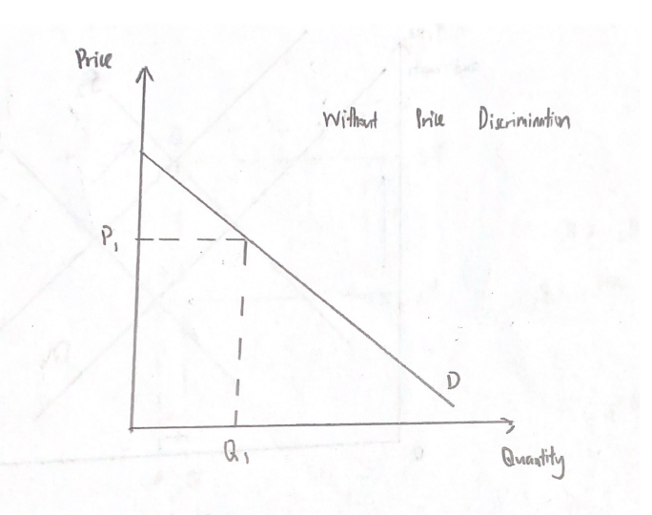

Royce is aware that different consumer groups belong to different demand curve. As we can see from the graph above, Royce can increase its revenue under price discrimination by setting different prices for different quantity of products, this pricing strategy allows Royce to increase its sales, Royce can sell more than before, as it satisfies different consumer group, consumer now have the flexibility to choose a pricing tier that suits their preferences and budget, customer satisfaction and loyalty are ensured. Although Royce is selling at a lower price, it is still able to generate profit as it benefits from economies of scale, the long run average costs will be lower. Hence, this pricing policy can maximize overall revenue and capture consumer surplus, which is the difference between what consumers are willing to pay and what they actually pay for the chocolate.